COUVA WEST SECONDARY SCHOOL.
UNIFORM REQUIREMENTS AND GUIDELINES

BOYS.
- White shirt (see image) with school’s monogram on pocket. Shirt must be worn neatly tucked into pants.
- ONLY plain white or tan undergarments to be worn under shirts.
- Green pants (see image), straight fit, 2” loops. NO slim or pencil pants.
- Plain black 2” belt, no studs or metal eyelets.
- Plain black shoes, no colored logo, design or lines etc. Plain black, clean socks.
- Hair must be appropriately styled and neatly worn for school. Hair must not cover the face. NO razor marks, mohawks, or coloured hair.
- A simple watch only – black or brown wrist bands.
- NO visible tattoo, rings, earrings, nose rings, chains, hand bands. (Please consult with Principal if Parents/Legal Guardians have any concerns).
- NO tooth adornments.
- Nails must be kept clean and neatly trimmed at all times.
- NO razor marks on eyebrows.
- N95 masks are recommended. Disposable masks are also accepted. If cloth masks are to be worn the colours accepted are dark green, dark blue or black (only plain colours and no prints ). It must be worn at ALL times while on the school’s compound. Any other masks must be approved by School Safety Officers and Administration.
- It is recommended that students have an extra mask in their possession in case one gets soiled during the school day.
- Students are not to share used masks.
- NO rags or bandanas are allowed.

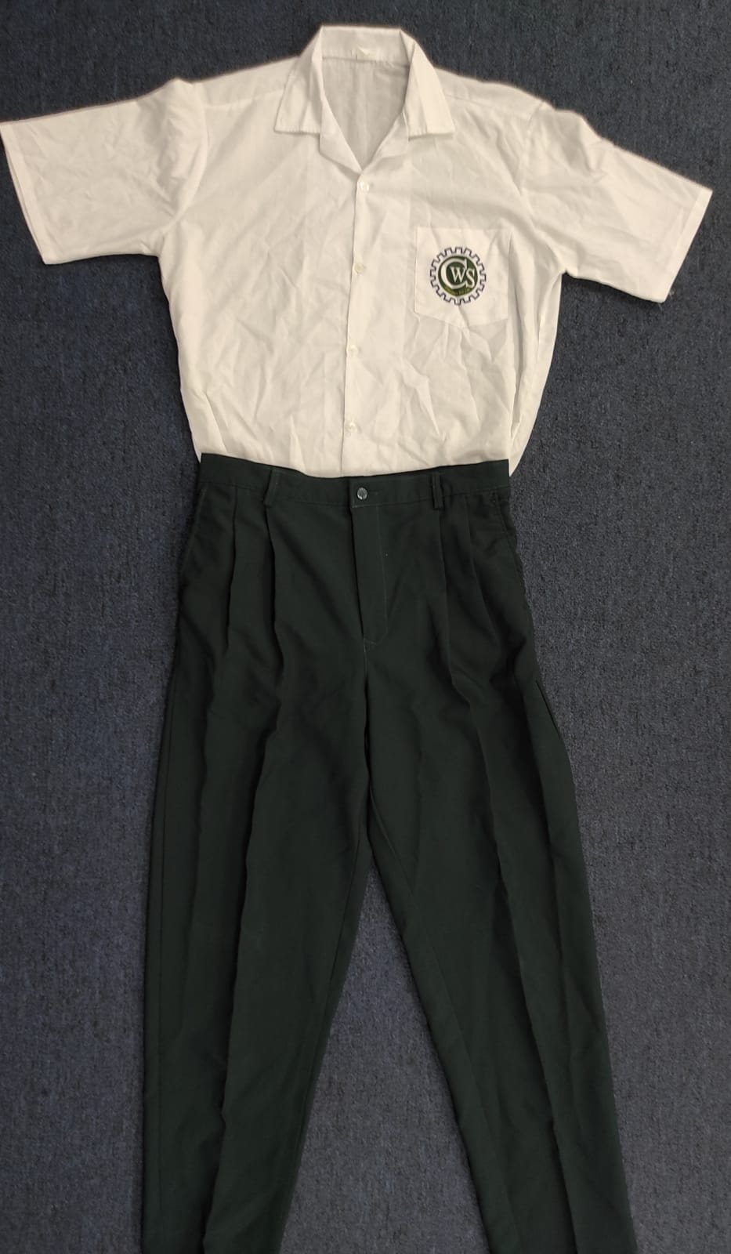
GIRLS.
GIRLS
- White blouse (see image) with school’s monogram on pocket, 3” waistband, all buttons to be worn over skirt. Blouse must not be tight fitting and must be buttoned all the way down.
- No colored undergarments, plain white or tan only.
- Blue (see image) plaid skirt, to be worn at least 3” under the knees, all the way around. No loops.
- Plain black shoes, no colored logo, design or lines etc. Plain black, clean socks.
- Hair must be appropriately styled and neatly worn for school. Hair must not cover the face. No razor marks, mohawks, colored hair. ONLY simple black or white hair accessories.
- A simple watch. Only one pair of simple stud earrings allowed on the ear lobe. (gold coloured, silver coloured or black). NO personalized or hoop earrings.
- No visible body tattoo, rings, nose rings, chains or hand bands. (Please consult with Principal if parents/guardians have any concerns).
- NO tooth adornment.
- No cosmetics/make up to be worn, including coloured nail polish, eyeliner, lip gloss etc.
- Nails must be kept clean and neatly trimmed at all times.
- NO razor marks on eyebrows.
- N95 masks are recommended. Disposable masks are also accepted. If cloth masks are to be worn, the colours accepted are dark green, dark blue or black (only plain colours and no prints). It must be worn at ALL times while on the school’s compound. Any other masks must be approved by School Safety Officers.
- It is recommended that students have an extra mask in their possession in case one gets soiled during the school day.
- Students are not to share used masks.
- NO rags or bandanas are allowed.

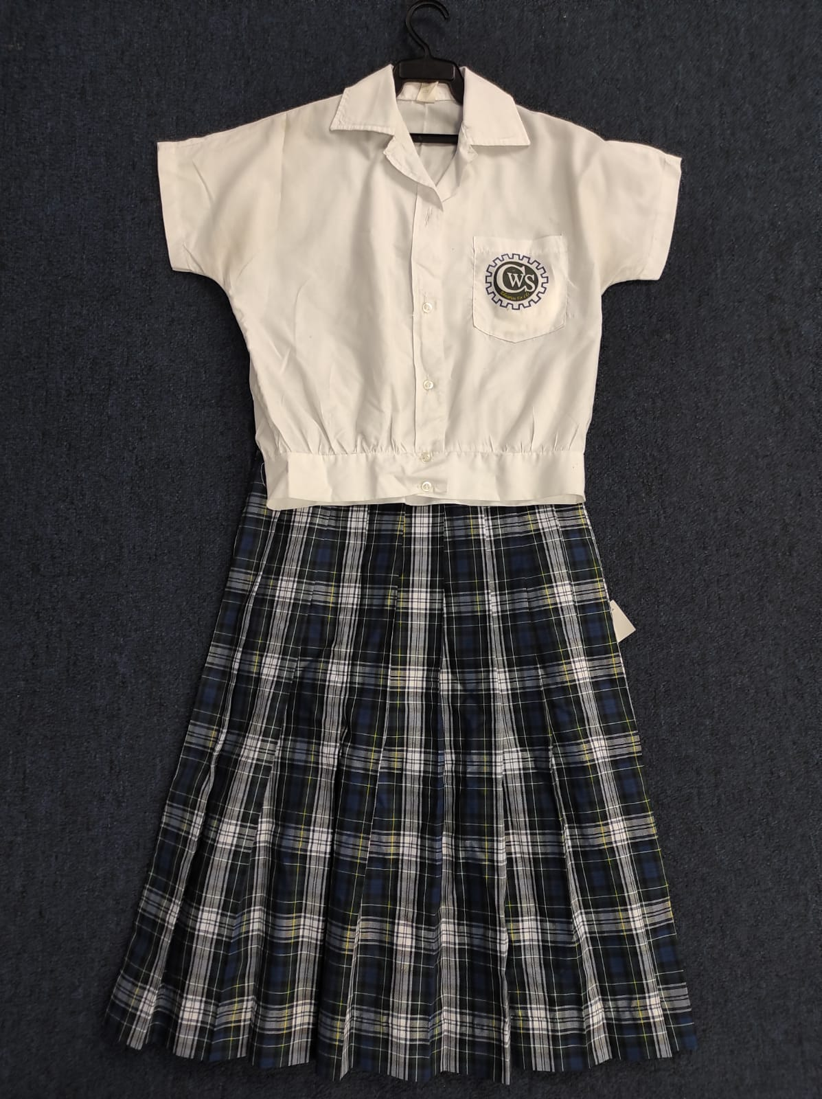PERSONAL/HYGIENE.

It is good practice, especially now that we are in a pandemic with a Covid-19 virus which is highly infectious to ensure that our students follow these guidelines as reminders:

- Uniform must be clean and worn neatly at all times.
- Students must maintain good personal hygiene habits, including bathing, brushing of teeth, and combing/brushing hair before reporting to school. Due to adolescence and bodily changes, it is recommended that all students use the necessary products to eliminate body odours, so all shared spaces will be comfortable for all persons.
- NO rags, washcloths allowed.
- Students are encouraged to practice regular washing and sanitizing of hands. Parents are asked to provide students with personal sanitizing agents so they can take personal responsibility for their well-being.( Wash sinks with soap are located throughout the school).
- NO Sharing of personal items such as books, pens, stationery, snacks/food, during face-to-face sessions at school.
- Students displaying flu-like symptoms would not be allowed on the compound. Please do not send them to school if they are unwell.
- Parents are advised to provide the school with copies of medical documents, if child/ward is suffering from any medical conditions.

Thank you very much for working with us in reinforcing our school policies.

Regards,
Wendy A. Jugmohansingh
Principal Secondary (Acting)

